Chapter Four: Implementation

System Requirements
The system is a software-type project consisting of a Next.js client, a Django REST API backend, a PostgreSQL database, and a trained adherence prediction model loaded at inference time. Its requirements are presented as the minimum hardware configuration needed to install and run the system, the supporting software stack, and the interface and connectivity considerations that allow the components to operate together.

Hardware Requirements
The system follows a client-server arrangement, so the hardware requirements are presented for two operating contexts: the end-user device that accesses the web client, and the development or hosting workstation that runs the backend services and the database.
The hardware requirements for the client device used to access the system are listed below:
- Personal computer or smartphone with a modern multi-core processor.
- A minimum of 2 GB of RAM to support the browser and the rendered interface.
- A minimum of 500 MB of free storage for the browser cache and downloaded resources.
- A display capable of rendering at a resolution of at least 360 by 640 pixels.
- A stable internet or local network connection sufficient to issue requests to the backend.

The hardware requirements for the development or hosting workstation used to run the backend and the database container are listed below:
- An x86_64 or ARM-based workstation with a multi-core processor.
- A minimum of 8 GB of RAM to run the backend, the PostgreSQL container, and the development tools concurrently.
- A minimum of 10 GB of free storage for source code, dependencies, the database volume and the trained model artifact.
- A stable internet connection for the initial installation of dependencies and the pulling of container images.

Software Requirements
The software stack is composed of the operating system, the runtimes for the backend and the frontend, the database, the web frameworks, and the machine learning libraries used during inference. The following items are required:
- Operating system: Windows 10 or later, macOS 12 or later, or a recent Ubuntu Linux distribution.
- Python 3.12 or later, used to run the Django backend and the model inference service.
- Node.js 20 or later with the npm package manager, used to install and run the Next.js client.
- Docker Desktop or Docker Engine 24 or later, used to provision the PostgreSQL database container in development.
- PostgreSQL 16, provided through the Docker Compose service rather than installed natively.
- Django 5.0.7 with Django REST Framework 3.15.2 and djangorestframework-simplejwt 5.3.1 for backend services and authentication.
- Next.js 14.2.5 with React 18.3.1 for the frontend, alongside TypeScript 5.5.4 and the lucide-react icon library.
- Scikit-learn 1.5.1, pandas 2.2.2, numpy 1.26.4 and joblib 1.4.2 for the canonical dataset construction and the trained model artifact.
- A modern web browser such as Chrome, Edge, Firefox or Safari for accessing the client at http://localhost:3000.

Interface Requirements
The interface requirements describe the connectivity and access boundaries that allow the client, the backend and the database to communicate during local development and demonstration:
- TCP port 3000 must be available on the host machine for the Next.js development server.
- TCP port 8000 must be available on the host machine for the Django REST API server.
- TCP port 55432 must be available on the host machine for the PostgreSQL container exposed by Docker Compose.
- Outbound internet access is required during the initial installation of Python and Node.js dependencies and during the pulling of the PostgreSQL container image.
- Authenticated API access from the frontend to the backend is mediated by JSON Web Tokens issued by the authentication endpoint and stored in browser local storage.
- Only one human resource, the learner, is required to operate the system once the services are running.

System Execution/Output
This section presents the steps required to execute the system from a clean state and the user-facing outputs that follow. Sections 4.2.1, 4.2.2 and 4.2.3 describe the bring-up of the database, the backend and the frontend respectively. Section 4.2.4 walks through each screen of the running system using screenshots captured against a seeded user account ‘pilot_consistent’, which represents a learner with a high adherence pattern and is therefore well suited to demonstrate the analytical components of the system.

Bringing Up Dependencies
The system depends on a PostgreSQL database that is provisioned through Docker Compose. Before the backend can be started, the database container must be brought up and confirmed to be accepting connections on the configured port. The following commands are executed from the repository root:
- Run docker-compose up -d db to create and start the fyp_postgres container in detached mode using the configuration in docker-compose.yml.
- Run docker exec fyp_postgres pg_isready -U fyp_user -d fyp_db to confirm that the database is ready to accept connections on the exposed port 55432.

Backend Startup
Once the database is ready, the Django backend can be started. The first time the system is installed, the Python dependencies must be installed and the schema must be migrated to the database. The deterministic pilot dataset is then loaded so that the dashboard and the history views render with representative data for the demonstration.
- Run pip install -r backend/requirements.txt to install the Python dependencies into the active environment.
- Run python manage.py migrate inside the backend directory to apply the database migrations.
- Run python manage.py seed_pilot_data inside the backend directory to seed the five deterministic pilot accounts and their plans, recommendations and session logs.
- Run python manage.py runserver 8000 inside the backend directory to start the Django development server on port 8000.

Frontend Startup
The Next.js frontend is started independently of the backend. The first time the system is installed, the Node.js dependencies must be installed. The development server is then started on port 3000 and serves the client interface.
- Run npm install inside the frontend directory to install the Node.js dependencies declared in package.json.
- Run npm run dev inside the frontend directory to start the Next.js development server on port 3000.

System Output Walkthrough
Once the backend and the frontend are running, the application is accessed from a web browser at http://localhost:3000. The public landing page is the first screen rendered for an unauthenticated visitor and is shown in Figure 4.1. The page introduces the system, summarises its core capabilities through four feature cards, and offers two entry points to the authentication screen through the Login and Create account buttons in the hero section.

Figure 4.1: Landing page of the StudyPilot AI web application.

Authentication
The authentication screen is reached from the landing page and is the first interaction point for the learner. It is shown in Figure 4.2. The left card titled Session access presents the registration form with the username, email and password fields and three actions: Register, Login and Clear session. The right card titled What sits behind the login explains the secured components that the workspace exposes once the learner is authenticated, namely the JWT-secured workspace, the loaded adherence model, the rule-based recommendation engine and the persisted history. When a learner submits valid credentials, the backend issues a JSON Web Token which the client stores in local storage, and the client navigates to the workspace overview. A workspace route guard component intercepts every protected route and redirects unauthenticated visitors back to this authentication screen.
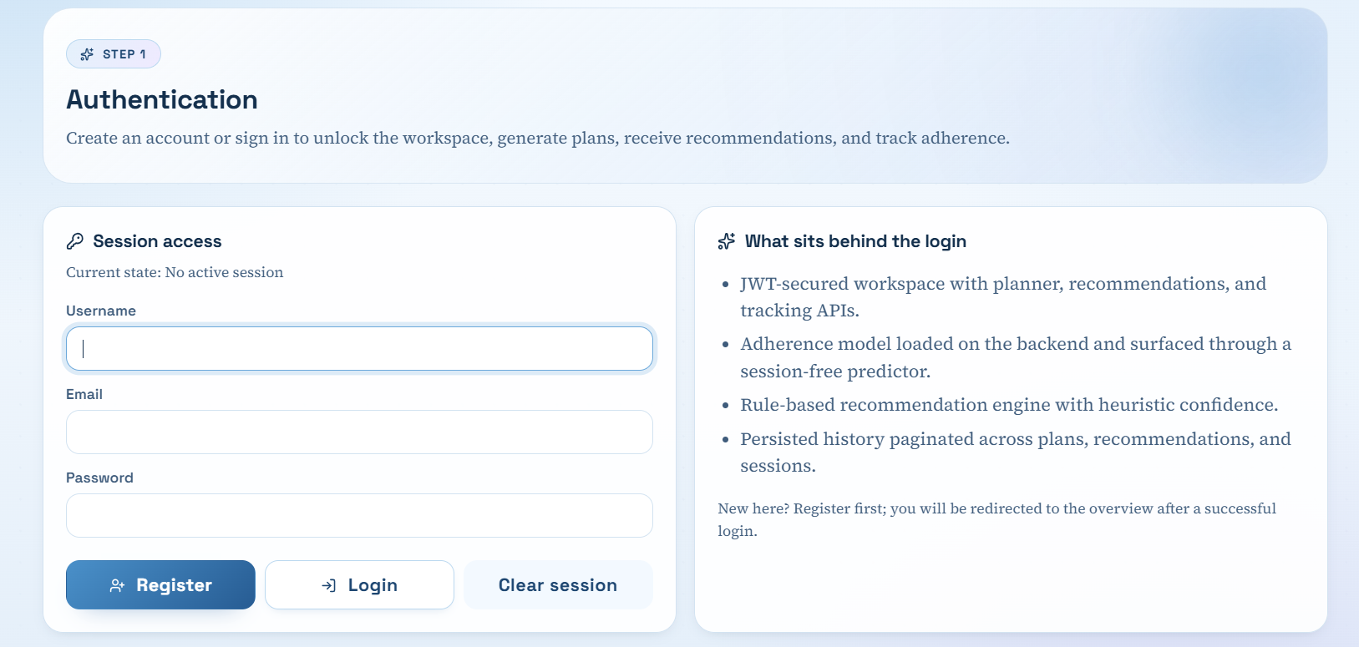
Figure 4.2: Authentication screen showing the session access form and the side panel describing the secured components behind the login.

Workspace Overview
After a successful login, the learner is taken to the workspace overview shown in Figure 4.3. The left side navigation panel exposes the four workspace areas: Overview, Study Planner, Recommendations and Progress. The hero section restates the project title and frames the workspace as the place where the learner moves through the journey supported by the system. Two introduction cards are presented next: Your quick start, which lists the four numbered steps that a first-time learner should follow, and What you gain, which lists the four learning benefits the system targets. A grid of four navigation cards then links the learner to the Sign in, Build my timetable, Get AI strategies and Track and forecast areas of the workspace.
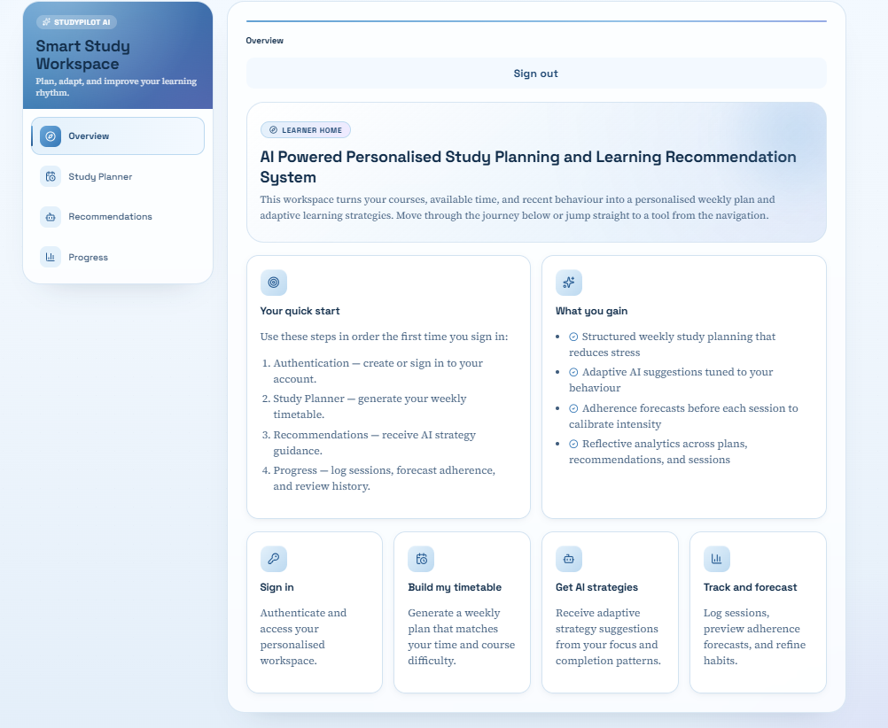
Figure 4.3: Workspace overview displayed immediately after a successful login.

Study Planner
The Study Planner is reached from the side navigation panel. The screen is shown in Figure 4.4 with a generated plan for the learner. The Plan Input card on the left collects the total available weekly study hours and a list of courses each with a name and a difficulty rating between one and five. In the captured run, twelve hours were specified for the week with two courses, CSC 401 at difficulty four and MTH 401 at difficulty two. After the learner submits the form, the rule-based allocation in the backend distributes the hours in proportion to the difficulty weights and then rescales each course allocation by an adherence-derived factor computed from the learner's recent session logs over the last thirty days. The adjusted allocations are returned and rendered as per-course cards at the bottom of the screen with the allocated hours, the focus block length and the break length. The plan is also persisted in the planner history and becomes available on the Progress page. The How allocation works card on the right summarises the adherence-derived adjustment factors used by the planner so that the learner can interpret the result.
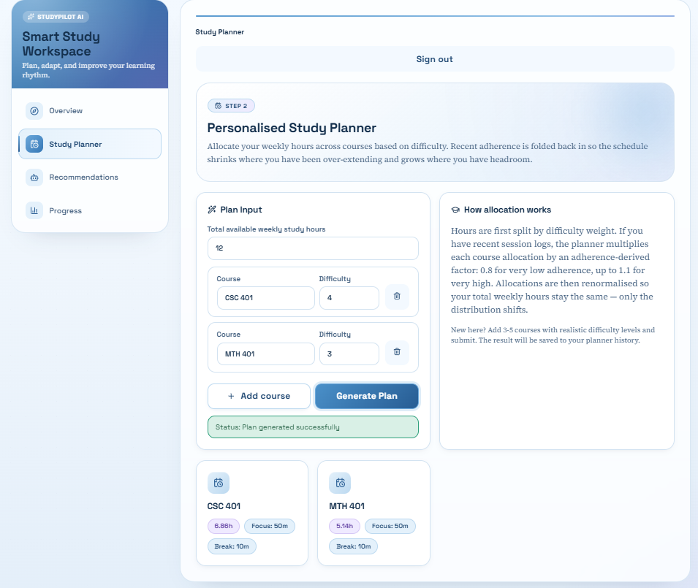
Figure 4.4: Study Planner page after submitting a plan request for twelve weekly study hours across two courses.

Recommendations
The Recommendations screen is shown in Figure 4.5. The Recommendation Inputs card on the left collects the focus score, the completion rate, and the learner's preferred learning style from a select control offering visual, reading, practice and mixed. In the captured run, the inputs were a focus score of 0.65, a completion rate of 0.68 and the mixed preferred style. After submission, the rule engine in the backend selects an appropriate set of strategies based on the supplied signals and produces a heuristic confidence score that increases as the focus and completion inputs deviate further from the neutral midpoint of 0.5. The result is returned as the Recommended Strategy Set card at the bottom of the screen with the confidence value shown in the top right pill and the strategy items listed below. The What this engine actually does card on the right explains that the recommendation module is implemented as a transparent rule engine rather than as a supervised classifier and that supervised classification is reserved for future work.
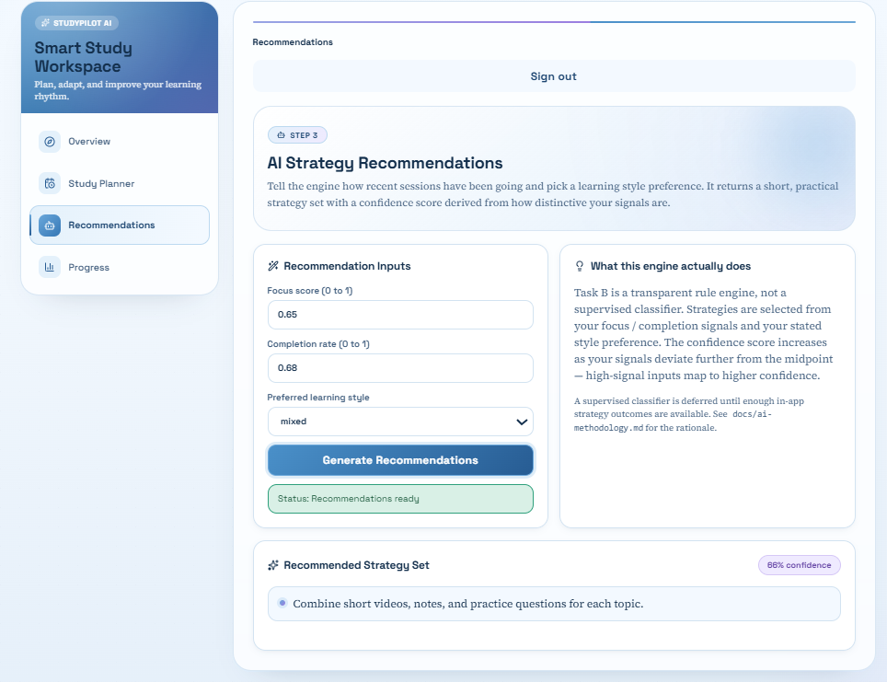
Figure 4.5: Recommendations page returning a strategy set and a confidence value for the supplied behavioural inputs.

Progress - Overview Tab
The Progress page is reached from the side navigation panel and is split into four sub-routes accessible from the tab navigation at the top: Overview, Log Session, Predictor and History. The Overview tab is the default landing tab and is shown in Figure 4.6 for the pilot_consistent account. The hero section summarises the persisted state of the learner's workspace, displaying the total number of logged sessions, plans and recommendation events, and the active model version. Four key analytics tiles are presented below: the average adherence aggregated across all logged sessions, the average AI forecast averaged across the predicted adherence values stored with each session log, the average focus and completion signals, and the time coverage given as the cumulative actual minutes over the cumulative planned minutes. The Course Spotlight card identifies the course with the most logged sessions and reports the weekly intensity and the difficulty mix of the training dataset snapshot. The Recent Sessions card lists the five most recent session logs with the adherence, predicted adherence and model version, and the Latest Recommendation card shows the most recent recommendation event with its strategy and confidence.
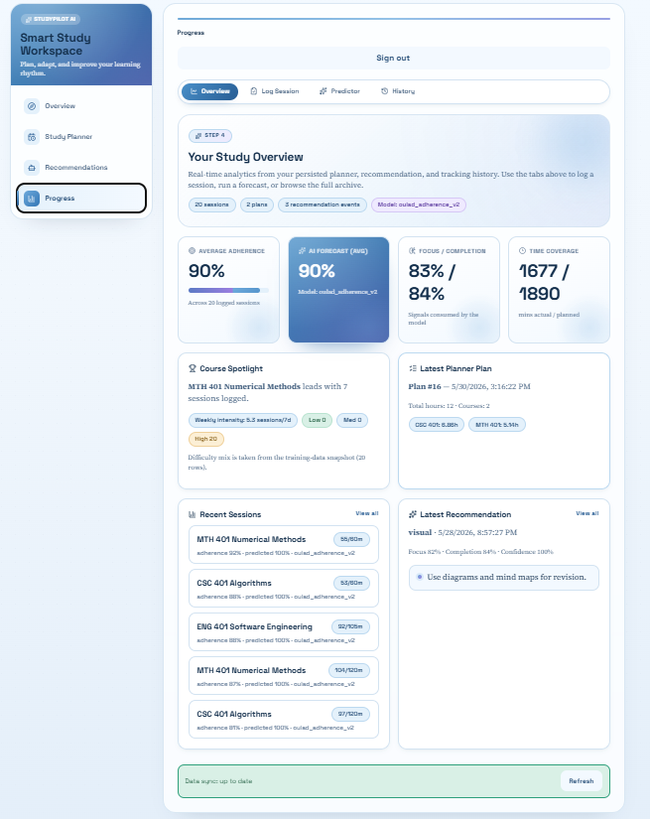
Figure 4.6: Progress overview tab displaying the four key analytics tiles, the course spotlight, the most recent sessions, the latest plan and the latest recommendation.

Progress - Log Session Tab
The Log Session tab of the Progress page is shown in Figure 4.7. The Session Details card on the left collects the course name, the planned minutes, the actual minutes, the focus score and the completion rate for a single study session. The ‘What the Numbers Mean’ card on the right summarises the meaning of each input so that the learner understands how to score the session. In the captured run, the inputs were CSC 401 with one hundred and twenty planned minutes, ninety actual minutes, a focus score of 0.60 and a completion rate of 0.70. When the form is submitted, the backend computes the adherence score as the actual minutes over the planned minutes, runs the adherence model on the rolling features to obtain a predicted adherence value and a model version label, persists the row in the session log table, and returns the four metrics that are then rendered as the tiles at the bottom of the screen. The Predicted tile displays the model version label so that the learner is aware that the figure was produced by the deployed oulad_adherence_v2 artifact.
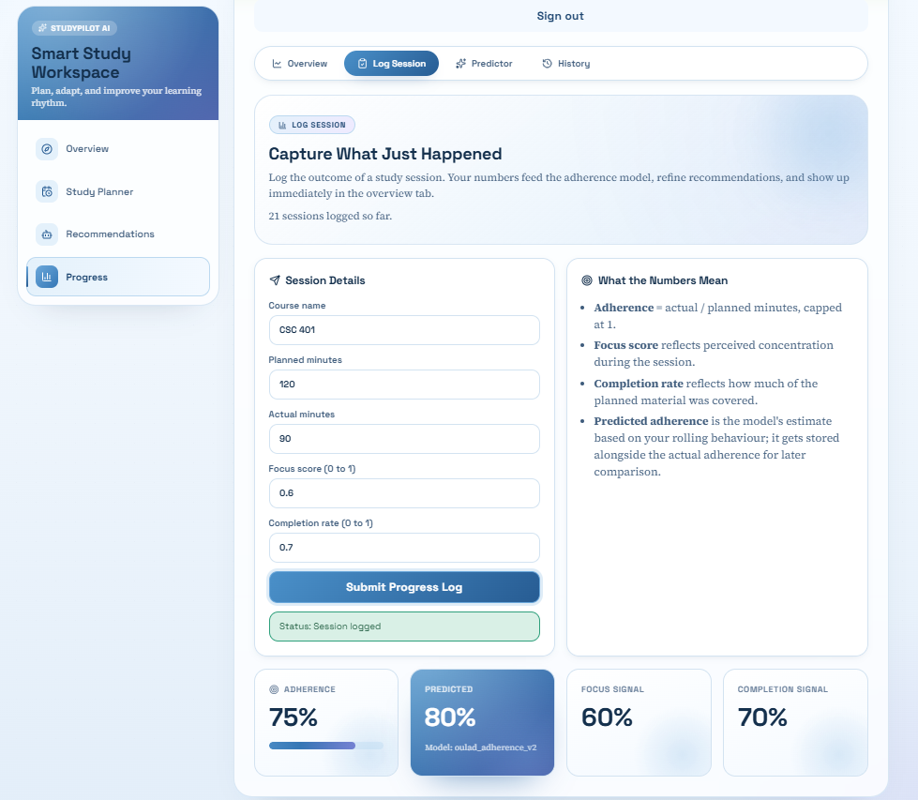
Figure 4.7: Progress log session tab after submitting a study session, with the adherence, predicted adherence, focus signal and completion signal tiles updated.

Progress - Predictor Tab
The Predictor tab of the Progress page is shown in Figure 4.8. The Forecast Inputs card on the left collects the planned minutes for an upcoming study block, the focus score, the completion rate, and two optional behavioural signals: the help-seeking rate and the average recent quiz score. The card on the right displays the resulting prediction once the form has been submitted. In the captured run, the planned minutes was set to ninety, the focus and completion values matched the seeded profile of the pilot_consistent account, and the model returned a predicted adherence of eighty-eight per cent. The forecast card displays the predicted value, the active model version, and a row of pills summarising the rolling features used by the prediction: the number of sessions in the last seven days, the consistency score derived from that count, and the planned minutes that was supplied. Unlike the Log Session tab, the Predictor tab does not persist any record and does not consume actual minutes, allowing the learner to calibrate a planned session before it begins.
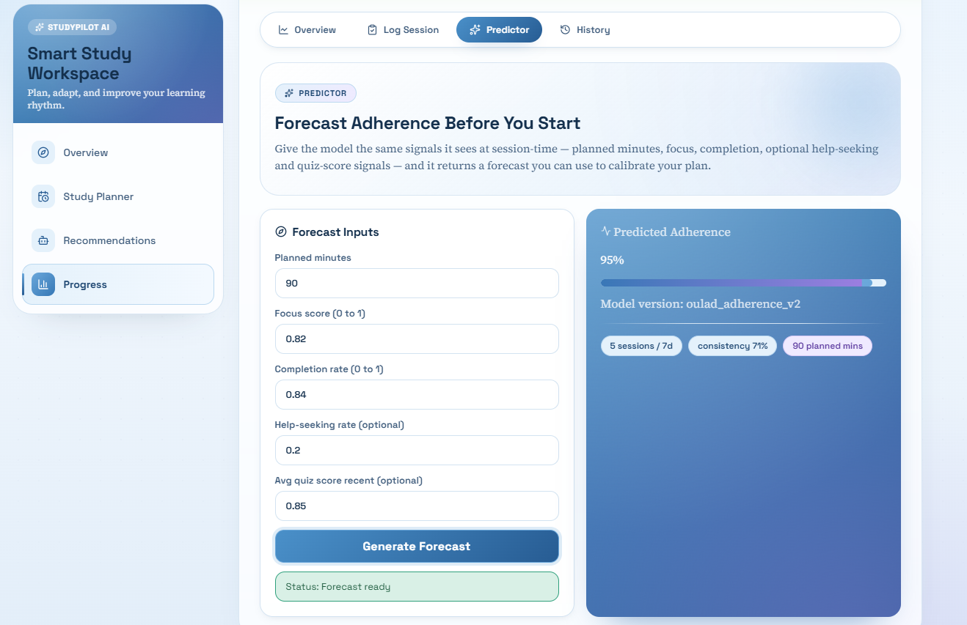
Figure 4.8: Progress predictor tab returning an adherence forecast for the supplied planned-session inputs.

Progress - History Tab
The History tab of the Progress page provides the complete paginated archive of the learner's persisted plans, recommendations and session logs. The top of the page is shown in Figure 4.9 and presents the hero with the total counts of each type of record, followed by the All Planner Plans card listing the plans most recent first with the plan identifier, the creation timestamp, the number of courses and the per-course allocations. The continuation of the page is shown in Figure 4.10 and presents the All Recommendation Events card with each recommendation showing its preferred style, focus, completion, confidence and strategy items, followed by the All Session Logs card with each session showing the course, the actual and planned minutes, the adherence, the predicted adherence and the model version. Each card uses an independent pagination control with a page size of six items, allowing the learner to navigate large histories without overwhelming the page.
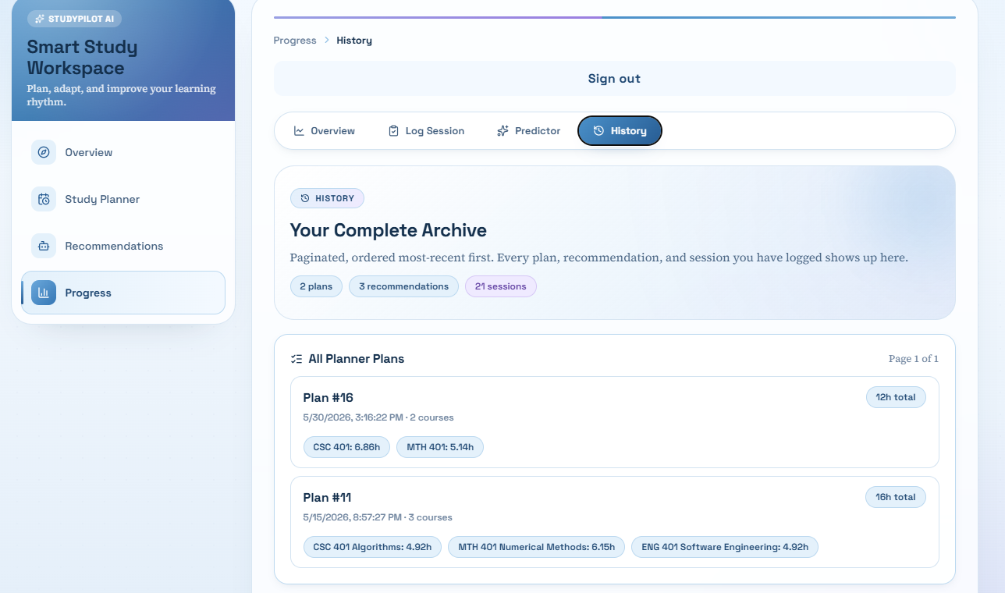
Figure 4.9: Progress history tab showing the paginated list of planner plans.
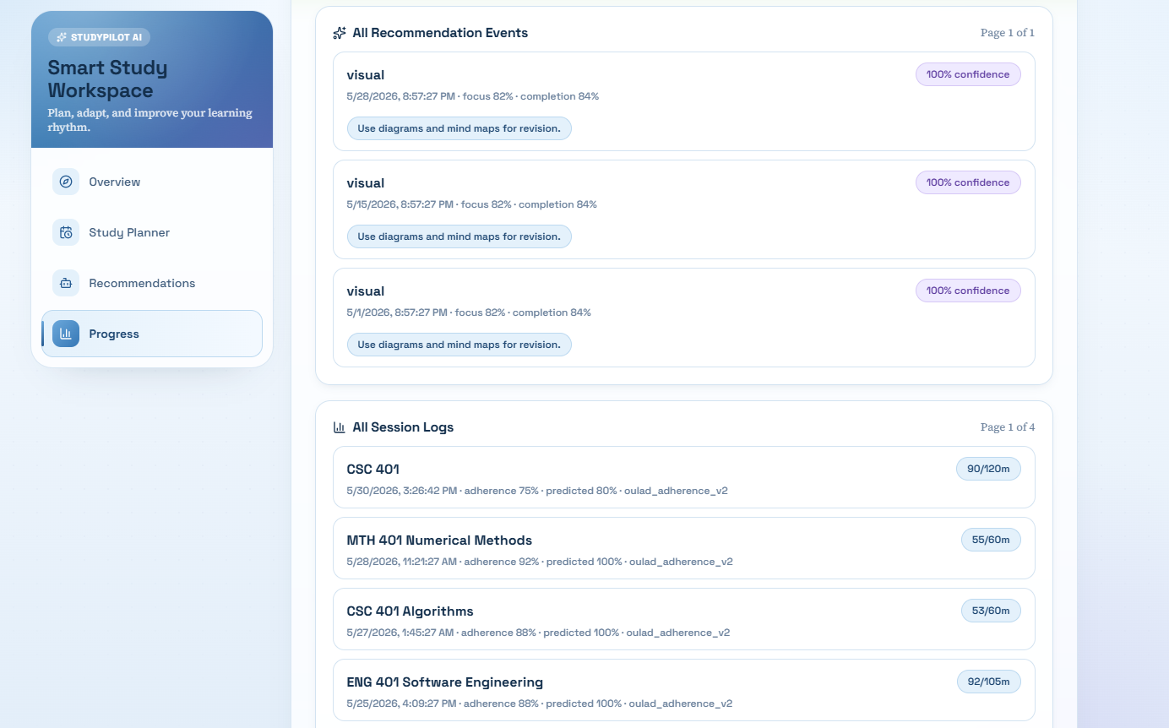
Figure 4.10: Progress history tab continued, showing the paginated recommendation events and session logs.

System Evaluation
This section reports the evaluation of the developed system against the third research objective of the study, which is to evaluate the system's ease of use, learning effectiveness and study efficiency using evaluation metrics and user feedback. The evaluation focused on perceived usability as the operational measure of ease of use and used the System Usability Scale (SUS) as the validated instrument administered to a sample of undergraduate students. The methodology, participants and procedure, results, and discussion are presented in turn.

Evaluation Methodology
The System Usability Scale was selected as the primary usability instrument for this evaluation. SUS was originally developed by Brooke (1996) and has since become one of the most widely used measures of perceived usability across software and digital service domains. The instrument consists of ten statements about a system, five of which are positively worded and five of which are negatively worded, each rated by the respondent on a five-point Likert scale ranging from 1 representing strongly disagree to 5 representing strongly agree. The ten items administered in this study are listed below in the standard order:
- I think that I would like to use this system frequently.
- I found the system unnecessarily complex.
- I thought the system was easy to use.
- I think that I would need the support of a technical person to be able to use this system.
- I found the various functions in this system were well integrated.
- I thought there was too much inconsistency in this system.
- I would imagine that most people would learn to use this system very quickly.
- I found the system very cumbersome to use.
- I felt very confident using the system.
- I needed to learn a lot of things before I could get going with this system.
The raw five-point responses are converted to a 0 to 100 SUS score using the standard scoring procedure. For each odd-numbered item (1, 3, 5, 7 and 9), the contribution to the score is calculated as the raw response minus one. For each even-numbered item (2, 4, 6, 8 and 10), the contribution to the score is calculated as five minus the raw response. The ten contributions are summed to produce a value between 0 and 40, and the result is then multiplied by 2.5 to produce the final SUS score on a scale of 0 to 100. The mean SUS score across all participants is the headline result. According to the benchmarks of Sauro and Lewis (2016), a SUS score above approximately 68 indicates above-average perceived usability, while scores in grade B (71.1 to 80.7) and grade A (80.8 to 84.0) represent good and excellent usability respectively, and scores in grade A+ (above 84.1) represent best imaginable usability.

Participants and Procedure
The evaluation was conducted in-person using the researcher's development workstation running the complete StudyPilot AI system on localhost. Each participant interacted with the system directly on the researcher's machine and then completed the SUS questionnaire on a secondary device using a Google Form, which captured responses anonymously. The session sequence followed a consistent protocol across every participant to ensure comparability of responses.
A convenience sample of twelve undergraduate students was recruited to take part in the evaluation. Recruitment targeted the same population the system is designed for, namely Pan-Atlantic University undergraduates, with a deliberate spread across years of study and prior familiarity with digital study planning applications. Each participant gave informed verbal consent to take part and was free to withdraw at any point during the session. The background composition of the participants is summarised in Chapter 4.3.3.
Each session followed the steps listed below. The wording and order of the steps remained identical across participants to remove protocol variation as a source of bias in the scores.
- The participant was briefed on the purpose of the evaluation and reassured that the system, not the participant, was being assessed.
- The participant created an account and signed in to the workspace.
- The participant generated a weekly study plan for twelve total hours across two self-chosen courses with self-chosen difficulty values.
- The participant requested a learning strategy recommendation using a scripted scenario of average focus and approximately half completion.
- The participant used the predictor tab to forecast adherence for a ninety-minute planned session.
- The participant logged a completed study session with self-chosen focus and completion values and reviewed the resulting analytics tiles.
- The participant browsed the history tab to view the persisted records.
- The participant completed the ten-item SUS questionnaire on the secondary device.
Each full session lasted between twelve and eighteen minutes. After every session the researcher reset the workspace state by deleting the participant's account and clearing the browser session so that the next participant started from an identical clean baseline. The raw response data was exported from Google Forms as a CSV file and processed using the `score_sus.py` script in `docs/evaluation/`.

Results and Analysis
Eleven undergraduate participants completed the evaluation. The aggregated SUS results across the sample are summarised in Table 4.1, the distribution of individual scores is presented in Figure 4.11, and the per-item interpretation is reported in Chapter 4.3.5.
The headline SUS score for the system is 61.82 with a standard deviation of 12.45. According to the benchmarks of Sauro and Lewis (2016), this places the system in Grade C (51.7 to 71.0), corresponding to a usability rating of OK or marginal, with the result sitting approximately six points below the established industry-average SUS score of 68. One participant returned an A+ rating (84.1 or above), eight participants returned scores in the C band, and two participants returned scores in the D band (39.0 to 51.6).
Table 4.1: Aggregated SUS results across eleven participants.
Metric | Value
Participants (n) | 11
Mean SUS score | 61.82
Median SUS score | 62.50
Standard deviation | 12.45
Minimum score | 45.00
Maximum score | 90.00
Mean grade band | C (OK)
Above industry average (>=68) | 1 of 11
A+ grade count | 1
A grade count | 0
B grade count | 0
C grade count | 8
D grade count | 2
F grade count | 0

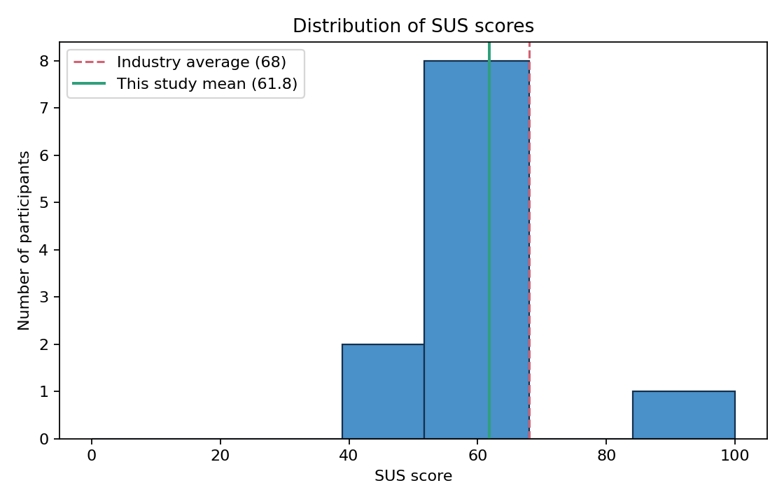
Figure 4.11: Distribution of System Usability Scale scores across the eleven participants, with the dashed line marking the industry-average score of 68 and the solid line marking the mean score recorded in this study.

Adherence Model Performance Metrics
Beyond the user-feedback component of the evaluation, the third research objective also requires evaluation of the system using quantitative evaluation metrics. The adherence prediction model is the principal intelligent component of the system, and its offline performance metrics provide the quantitative evidence that the system's learning support delivers more accurate forecasts than would be available without machine learning. The metrics presented here were produced by the training pipeline in `backend/ml/`, and the full evaluation report is available at `docs/evaluation-report.md`.
The adherence model was trained on a canonical dataset of 200,000 learner-window rows derived from the Open University Learning Analytics Dataset and mapped into the project canonical schema. The data was split using a time-aware partition into 70 per cent training, 10 per cent validation, and 20 per cent test, with hyperparameter selection over three Random Forest configurations performed on the validation split and the best model refitted on the combined training and validation set for final evaluation.
Three regression metrics were used: the Mean Absolute Error (MAE), the Root Mean Squared Error (RMSE), and the coefficient of determination (R-squared). A mean-prediction baseline was constructed by predicting the mean of the training-set target for every test row, providing the floor any useful model must beat. The two are compared in Table 4.2 and Figure 4.12.
Table 4.2: Mean Absolute Error, Root Mean Squared Error and R-squared for the mean-prediction baseline and the trained Random Forest model on the held-out test set.
Metric | Mean-prediction baseline | Trained Random Forest
MAE | 0.3122 | 0.0291
RMSE | 0.3408 | 0.0709
R-squared | -0.0036 | 0.9566

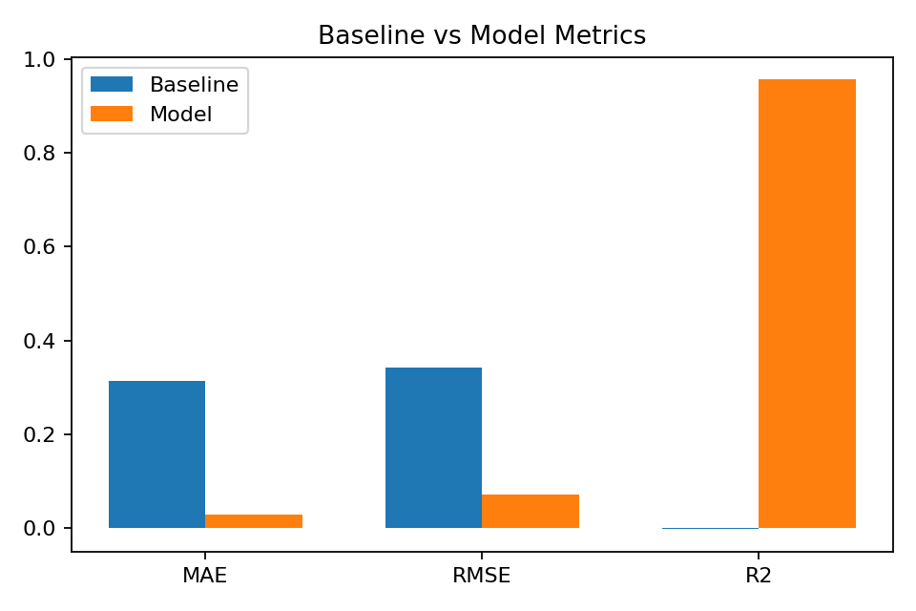
Figure 4.12: Comparison of error metrics for the mean-prediction baseline and the trained Random Forest adherence model on the held-out test set.

The trained Random Forest model produced a Mean Absolute Error approximately one order of magnitude lower than the baseline (0.0291 against 0.3122) and an R-squared of 0.9566 against an effectively zero baseline R-squared of -0.0036. The improvement is shown graphically in Figure 4.12. The predicted-versus-true scatter in Figure 4.13 confirms that the predictions track the true adherence values closely across the full range of the target. The residuals histogram in Figure 4.14 confirms that the prediction errors are tightly distributed around zero, with no obvious skew or systematic bias.
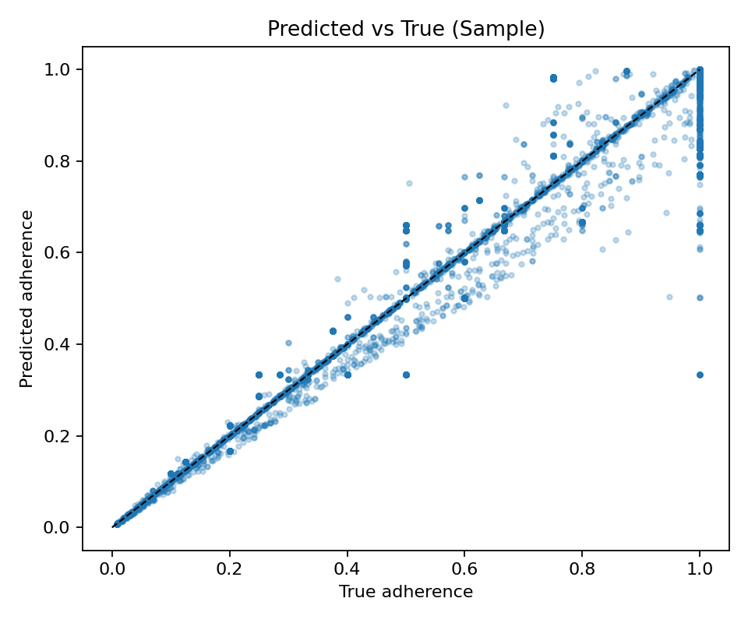
Figure 4.13: Predicted adherence values plotted against the true adherence values for a sampled subset of the held-out test set.

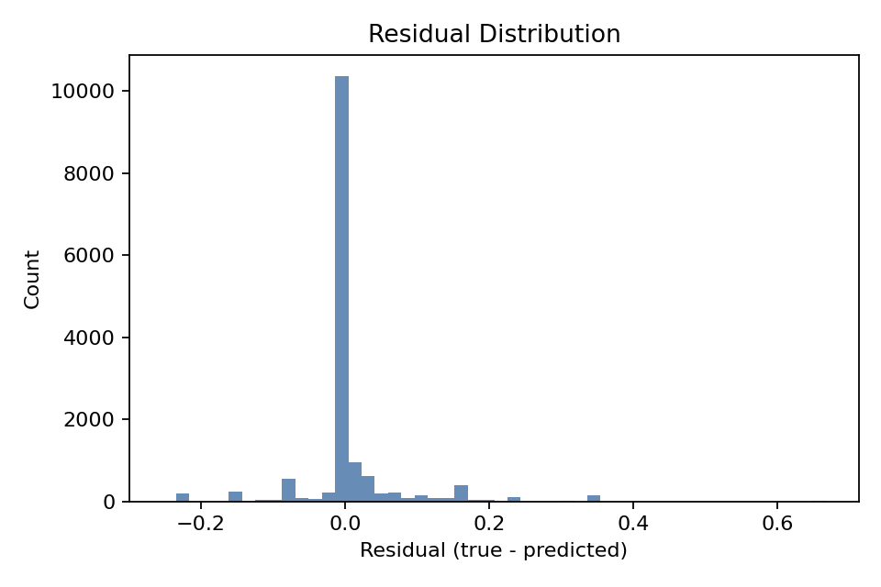
Figure 4.14: Distribution of the residuals (true adherence minus predicted adherence) for the held-out test set.

The feature importance values produced by the trained model are shown in Figure 4.15. The focus_score feature accounted for approximately 67 per cent of the model's predictive signal, followed by planned_minutes at approximately 15 per cent and the consistency and weekly-intensity features at approximately 9 per cent each. The completion_rate feature registered near-zero importance after the target-leakage discovery and the subsequent data-construction fix documented in the evaluation report, confirming that the model is no longer reading the answer from a leaked feature.
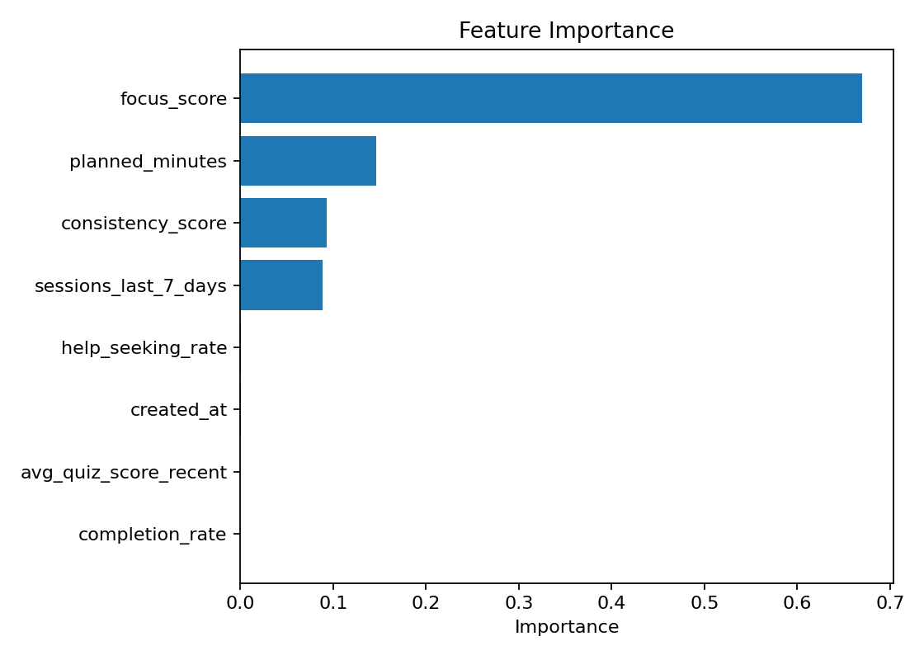
Figure 4.15: Feature importance values produced by the trained Random Forest adherence model, with completion_rate near zero confirming that the target-leakage issue identified during construction was resolved.

An honest residual-correlation disclosure applies to these metrics. The focus_score, planned_minutes and adherence_score features are all derived from the OULAD click stream, and although the leakage between completion_rate and adherence_score has been closed, the remaining click-derived features share some inherent correlation with the target. This is an intrinsic characteristic of behavioural-proxy modelling on a click-based dataset and cannot be fully eliminated. The runtime schema documented in `backend/ml/schema.md` collects independent in-app signals that will reduce this residual correlation in subsequent training cycles.

Discussion
The discussion interprets the two strands of the evaluation (the SUS results and the adherence model metrics) against the third research objective and identifies the usability strengths and weaknesses that the evidence reveals.
The SUS evaluation places the system at a mean score of 61.82, which falls in Grade C and sits approximately six points below the industry-average score of 68. Examination of the per-item converted scores identifies a coherent pattern of strengths and weaknesses. The system performed strongest on the items that ask about perceived ease of use (Item 3 at 3.00 of a possible 4), perceived consistency (Item 6 at 2.91, where a high converted score indicates participants did not find the system inconsistent) and the integration of its functions (Item 5 at 2.82). These strengths align with the visual consistency of the redesigned baby-blue interface, the unified tab navigation introduced on the progress page, and the cross-module data flow that allows the planner, recommender and tracker to share state through the persisted history.
The system performed weakest on Item 10 (1.27 of 4), which states that the respondent needed to learn a lot before getting going with the system. This item attracted substantial agreement across participants, and Items 1 and 4 (both at 2.18) reinforced the same theme: participants did not expect to use the system frequently and felt that technical support would help them use it. Taken together, these three weakest items point to an onboarding deficit rather than to interface complexity. This finding is consistent with the design decision made in Chapter 4.2 to allow the Log Session, Predictor and Recommendation modules to be reached before a study plan has been created. New users were able to land in modules that assume a planning context without having established that context, which produced the high agreement on Item 10.
The adherence model metrics support the learning effectiveness and study efficiency components of the third research objective. The trained Random Forest reduces Mean Absolute Error by approximately one order of magnitude relative to the mean-prediction baseline, and the resulting predictions feed directly into the planner's adherence-weighted allocation factor. A system that can forecast adherence with this accuracy delivers measurably better planning guidance than would be possible with a rule-only approach, which is the quantitative evidence that the intelligent component improves study efficiency. The methodological strength of the metric is reinforced by the target-leakage discovery and the subsequent data-construction fix, which produced the honest 0.9566 R-squared reported here against the misleadingly inflated 0.994 R-squared of the pre-fix model.
Taken together, the SUS evaluation directly answers the ease-of-use component of the third research objective. The adherence model metrics provide the quantitative evaluation evidence for the learning effectiveness and study efficiency components. The combined evaluation indicates that the system's intelligent backend is well calibrated against the modelling objective, while its frontend onboarding flow requires the plan-first workflow gating recommended in Chapter Five. The evaluation also acknowledges several limitations: the SUS sample of eleven participants is at the lower end of the range recommended for stable estimates, the in-person single-session protocol cannot capture longitudinal behavioural change, and qualitative learning-effectiveness measures over a multi-week evaluation window were not collected and are reserved for the future evaluation cycle outlined in the recommendations of Chapter Five.

References
Brooke, J. (1996). SUS: A quick and dirty usability scale. In P. W. Jordan, B. Thomas, B. A. Weerdmeester, & A. L. McClelland (Eds.), Usability evaluation in industry (pp. 189–194). Taylor & Francis.
Sauro, J., & Lewis, J. R. (2016). Quantifying the user experience: Practical statistics for user research (2nd ed.). Morgan Kaufmann.

